Katharina Elberti Event Story | April 9, 2014

Buzz Williams Announced as Virginia Tech’s Men’s Basketball Head Coach

BLACKSBURG, Va. – Virginia Tech Director of Athletics Whit Babcock introduced Buzz Williams as the new men’s basketball head coach at a press conference in Cassell Coliseum Monday, March 24.
“It’s not where we have been as a program or where we are now, but rather where we are headed, where we want to go, and who we aspire to be,” Babcock said. “Buzz Williams will work hard to build our program to National promise. It will take time, but we will give him that time and he will build it right.”
Babcock addressed the “very difficult decision” made the previous week regarding Virginia Tech’s decision to part ways with head coach James Johnson after his two seasons and 22-41 record. Babcock thanked Johnson for his time at the university and for the way he represented Virginia Tech.
Following Babcock’s opening remarks, the HokieBird escorted Williams and his wife, Corey Norman, into Cassell Coliseum. The former Marquette men’s basketball head coach was greeted by a pep rally of cheerleaders, the Virginia Tech HighTechs, loud music, and a buzzing crowd.
Waving to the crowd, Williams took the podium and led the 2,000 attendees in a chant of “Old Hokie.” Williams addressed the crowd and explained why he was humbled to be selected for the head coaching position and excited for the opportunity it presented. “I think this program is a sleeping giant,” Williams declared. “There’s a lot of work to be done. One thing I can assure you is that you’ll have my heart, you’ll have my soul, I’ll work at it every single day, and I’ll do right by this institution, this department and this program.”
Williams took a moment to recognize the prominent figures in the crowd: Virginia Tech Hall of Fame men’s basketball players Bimbo Coles and Adrian “Ace” Curtis; former Virginia Tech men’s basketball player and current Business Information Technology professor in Virginia Tech’s Pamplin College of Business, Dr. Quinton Nottingham; and former Virginia Tech men’s basketball player and former assistant coach, Scott “Scooter” Davis. Williams mentioned each gentleman by name and offered him a round of applause. Williams also recognized Virginia Tech football head coach Frank Beamer, expressing his admiration for Virginia Tech icon and his coaching techniques. “I can’t wait to meet [Frank Beamer] and learn everything I can about his coaching techniques,” Williams said.
Members of the Virginia Tech Athletic and Recreational Sports Departments were among the crowd. “I think that the press conference energized the student body,” Assistant Director of Recreational Sports Alan Glick said. “People are excited to have a new coach, especially a guy that’s taken his team to the NCAA tournament.” Glick is optimistic that Williams can be as successful with the Hokies as with Marquette, and is looking forward to seeing Williams’ new recruits and what the future holds for the men’s basketball program.
Williams focused his address not only on his ambitions for the program itself, but for the young men whom he will be coaching. “The reason I came here is for the challenge of building this program into something great,” Williams said. “That is deeper than just winning; it’s the residual affect.” He emphasized his dedication to molding the young men into great basketball players, students, future husbands and fathers.
Virginia Tech freshman and aspiring 2014 season walk-on Kendall Dillard thinks Williams will be a perfect fit for the university. “Johnson was a great coach, but he treated it like a job and kept his family-life separate,” Dillard said. “I know that makes sense for most jobs, but when you’re a coach playing at this level, I feel as if you have to live and breathe for your job and your team. That’s something I’m confident Williams will do. I would love to play under him.”
Before taking questions from the media, Williams had the current men’s basketball players huddle and lead Cassell Coliseum in a “Let’s Go, Hokies” chant. Williams then expressed his desire to fill all 9,847 seats in the basketball arena with cheering fans next season.
Williams earned his bachelor’s degree in kinesiology from Oklahoma City University and a master’s degree in the same discipline at Texas A&M University-Kingsville.
He worked as the men’s basketball head coach at the University of New Orleans during the 2006 season and, most recently, at Marquette University from 2008 to 2014. Williams served as the assistant men’s basketball coach at Oklahoma City University, the University of Texas at Arlington, Texas A&M University-Kingsville, Northwestern State University, Colorado State University, and Texas A&M University.
Williams is the founder of Buzz’s Bunch, a program that allows special needs children to attend a basketball summer camp hosted exclusively by Williams and the Marquette basketball team. Williams intends to continue the program at Virginia Tech by including the special needs and Special Olympics program participants in the New River Valley.
Williams and his wife, Corey Norman, have two sons, Calvin and Mason, and two daughters, Zera and Addyson.

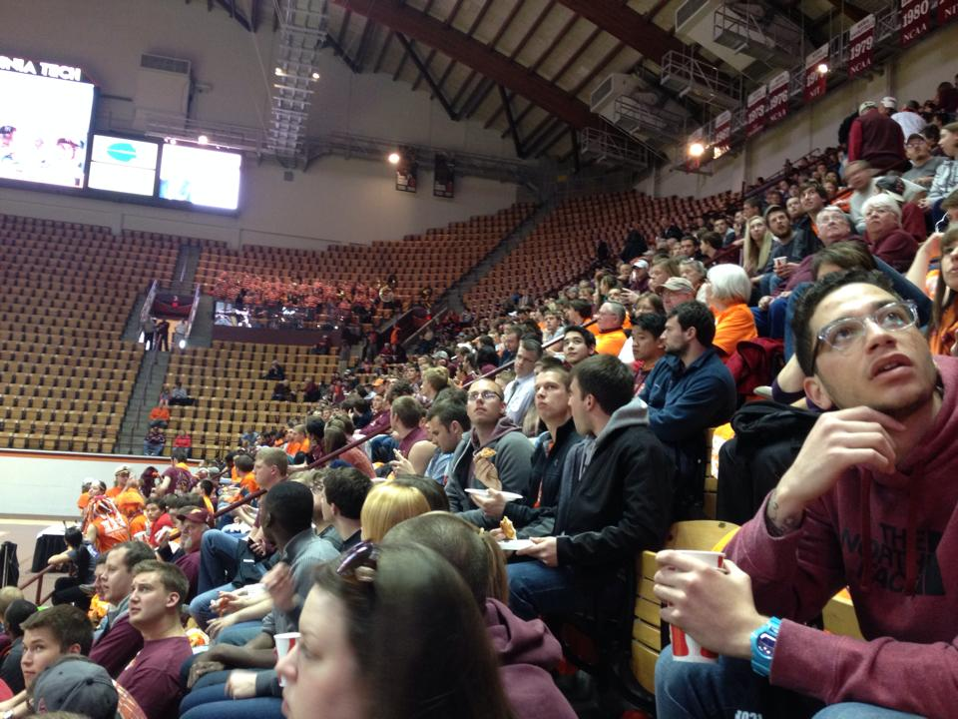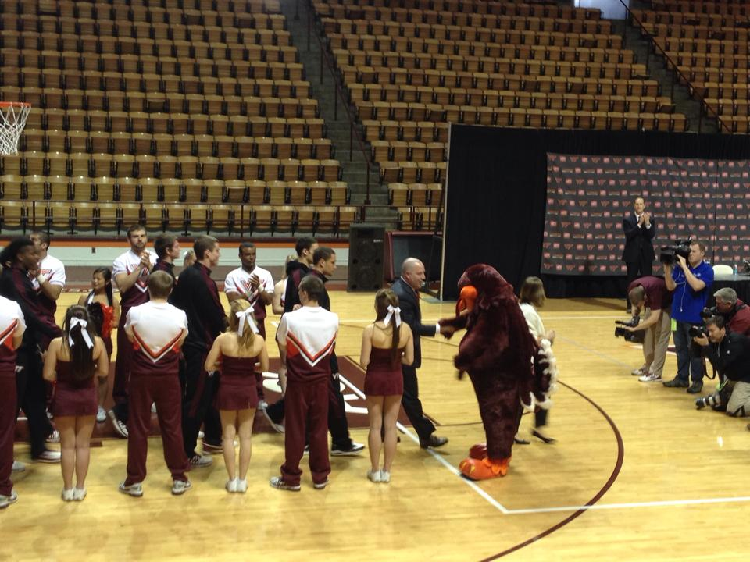
Image 1 Image 2

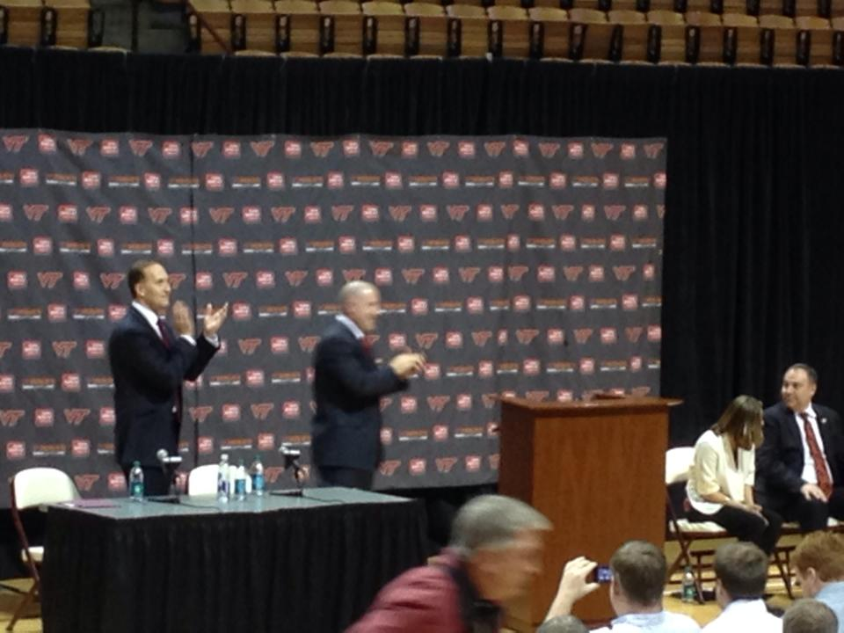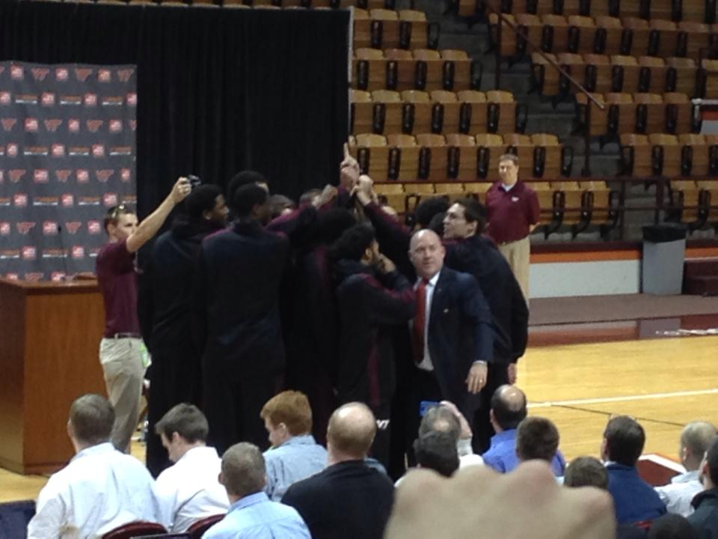
Image 3 Image 4

Image 1: Fans crowd Cassell Coliseum for the March 24 press conference.
Image 2: Buzz Williams shakes hands with his new mascot, the HokieBird.
Image 3: Athletic Director Whit Babcock introduces Buzz Williams to the crowd.
Image 4: Buzz Williams leads Cassell Coliseum in an "Old Hokie" chant.

Images taken by Katharina Elberti

Intended Audience:
- Individuals who are interested in the Virginia Tech men’s basketball program and were unable to attend the press conference
- Individuals who are interested in the Virginia Tech men’s basketball program and were able to attend the press conference but want a re-cap of what happened
- Individuals who are interested in the Virginia Tech men’s basketball program but were unaware that the press conference was happening and would like to know what happened

