Katharina Elberti Feature Story | 4 May 2014

Blumenthal Trades In Hat for Grad Cap

Ben Blumenthal, a senior majoring in computer engineering, is known around campus as "The Mad Hatter," yet few people know the story behind his eccentric fashion choice.
“Back then I was just a weird guy wearing a hat,” Blumenthal said of his debut of the affectionately named Mad Hatter Hat in the fall of 2012.
The extravagant masterpiece atop Blumenthal’s brow is modeled after the hat worn by “The Hatter,” one of the fictional characters in Lewis Carroll's novel Alice’s Adventures in Wonderland. Carroll’s character comes by his name after he offends Time. Time then halts himself for The Hatter, therefore condemning him to stay at 6:00pm forever and driving him to madness.
So why does Blumenthal wear the hat?
“Part of it is, I’m mad, therefore I require a hat,” he joked. “The second answer I give is I’m a huge fan of Alice in Wonderland but I don’t cross-dress. I just don’t. Third, college is pretty much the only environment where I’ll [be able] to get away with it on a daily basis; I might as well take advantage of it!”
Aside from some help with sewing, Blumenthal designed and executed the creation of the iconic hat himself.
“Part of why I made it myself is I wouldn’t feel right calling myself The Hatter if I didn’t actually make the hat myself, therefore becoming an actual hatter!” Blumenthal explained.
The body and main support structure of the hat are constructed out of a thin, plastic cutting board, therefore enabling the hat to hold its shape. In turn, the brim keeps its shape with a wire that is usually only used for things such as power lines.
Five pins that were either donated or made encompass the hats brim. The iconic gold teapot pin was found at a thrift store where Blumenthal was “unable to resist” making the purchase. The silver leaves were a gift from the Science Fiction Fantasy Club, as was the Zombie Survival Plan pin. A cartoon image of Alice as interpreted by American game designer American McGee is the face of the fourth pin.
A final pin carries more personal meaning for Blumenthal. “It is a symbol I designed for myself,” he said of one of a kind, triangular design shape. “It’s just a little symbol but it means a lot. It’s also the only thing I’m willing to get tattooed on my body because I made it and therefore no one can tell me what the hell it means!”
And where would a Mad Hatter be without his trench coat?
Having a specific idea of what he wanted, Blumenthal commissioned family members to help design his second statement piece; the two trench coats. The coats were intricately crafted with two hooks that enable the seemingly normal coat to transform into a classic Renaissance-style, coat-tailed masterpiece.
“[With the coats] I get to show off,” he chuckled.
Many wonder why Blumenthal stopped after one hat. “I put enough work into making this particular shape and everything. It would be fun to have different hats, but at the same time it’s not going to distinguish me any more or less.”
With a fashion choice of such magnitude there are bound to be public responses.
Blumenthal was quick to recall the weirdest response he’s received in regards to his fashion choice, which happened to be from Virginia Tech professor. “He essentially requested me to make him a hat,” he recalled. “He wanted a purple and gold one; essentially the not-so-well-named ‘pimp hat.’ I didn’t end up going through with the commission but I found it amusing.”
Although he admitted it would be fun if everyone were to become interested in Victorian-age hats again, the hat-making business is not an endeavor Blumenthal intends to pursue. “It wouldn’t be a huge amount of work but it’s just something I want to keep for me,” he said.
In the past few weeks the popular VT Confessions Facebook page has featured a few Virginia Tech students’ confessions about The Mad Hatter.
The first confession was from an individual whom encountered Blumenthal outside of Dietrick Dining Hall. Blumenthal remembers a woman offering free candy and condoms to passersby. “When she offered them to me I ended up saying something to the effect of ‘I do not currently have a girlfriend and I do not see myself having sex with anyone who is wooed by candy,’” he chuckled as he mimicked uncomfortably presenting a lollipop to an imaginary woman.
However, not all of the recent VT Confessions about Blumenthal’s alter ego have been approving. One post read: ‘To be honest, I am a little creeped out by The Hatter guy.” At first, mention of the negative post resulted in a noticeable droop to his expression. However, Blumenthal then exclaimed his delight at the responses that the negative confession received from other students such as “You shouldn’t be creeped out; he’s awesome!” to “He’s just a friendly guy.”
“There was somewhere around 70 posts backing me up. It was a good little power-trip of mine,” he laughed. “It was a little burst of noticeable popularity that [showed that] there are a significant number of people out there who like [the hat].”
The Mad Hatter’s social media presence has also increased with an image of him, clad in hat and trench coat, acquiring the profile picture spot on the People of Blacksburg Facebook page. “I was not completely expecting to be on the front page of anything, but there I am!” he said. “I find it slightly amusing.”
“Ben is one of the most interesting people I have met at Virginia Tech,” New Residence Hall East Resident Advisor Giancarlo Di Biase said of his resident and suitemate. “I remember the first time I saw him, I asked why he always wears the hat, and his response was ‘Why not?’ I think it was good answer.”
In 2010 Blumenthal was an ambitious new Hokie who had just graduated from Princess Anne High School with over 30 transferable college credits. After accepting his offer to attend Virginia Tech, he ventured to discover the origins of his new schools’ peculiar mascot. “I made the mistake of trying to get ahead of the game,” he joked. Through his research he discovered Virginia Tech’s two classic cheers – “Old Hokie” and “Gobblers” – and how they played a pivotal part in deciding the universities mascot: the Hokie. “Hokie. Definition: a desperate attempt not to be called the Gobblers!” he boomed as he fell into tremendous laughter.

To his parents chagrin, in his four years at the university Blumenthal has never attended a Virginia Tech football, basketball, or soccer game. “To be honest I just couldn’t give a hoot,” he said. “I have never found an interest in sports.”
Blumenthal is an active member of the Science Fiction and Fantasy Club on campus but can often be found either playing tabletop RPGs with friends or lounging in his room enjoying copious amounts of British television.
“I’ve had a couple of weird roommates before, but none like Ben,” sophomore James Hillmer poked fun of his current roommate. “I had never heard of ‘the hat guy’ before this year but he’s really a normal, great person. He’s introduced me to the secretly nerdy, illuminati side of Virginia Tech,” Hillmer laughed.
In a few short weeks Blumenthal will be graduating and is relieved to finally be finishing the education stage of his life. “They put a big deal on the dress code so I don’t think they’re going to let me wear my hat at graduation,” Blumenthal chuckled.
As Ben heads off into the real world to work in the internal computer departments of Verizon, the future of the hat is questionable.
After two years and an unknowingly iconic fashion choice, The Mad Hatter will be leaving Virginia Tech for good. However, Ben Blumenthal is not one for goodbyes or validation.
“I don’t really need people to know much about me. I will continue living regardless of the recognition.”
Who will be the next student to follow in Blumenthal’s footsteps? We will have to wait and see.

My article was published on Wednesday, May 7, 2014 in The Collegiate Times. Here is a link to the article: http://www.collegiatetimes.com/lifestyle/article_f9992d38-d556-11e3-adca-001a4bcf6878.html

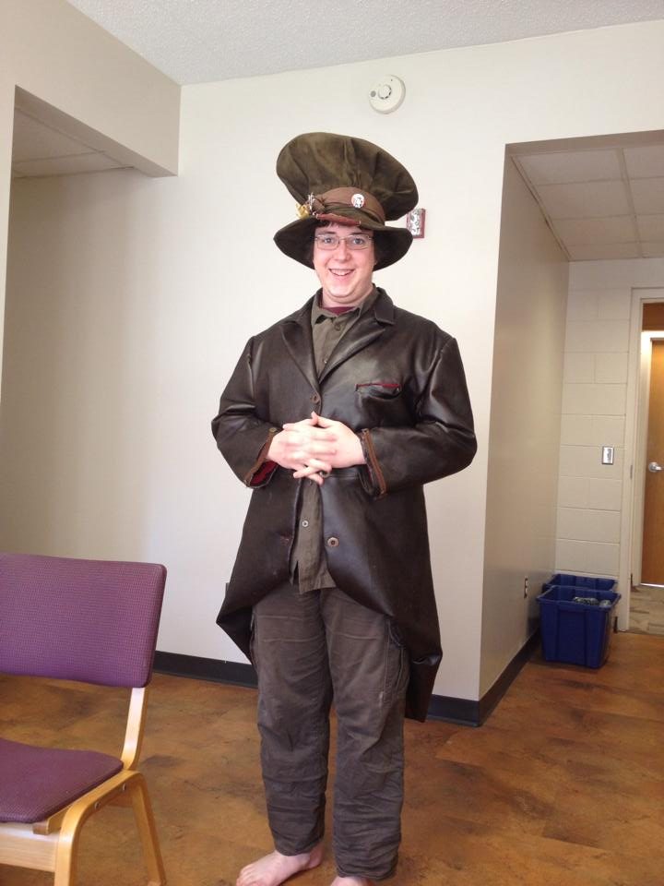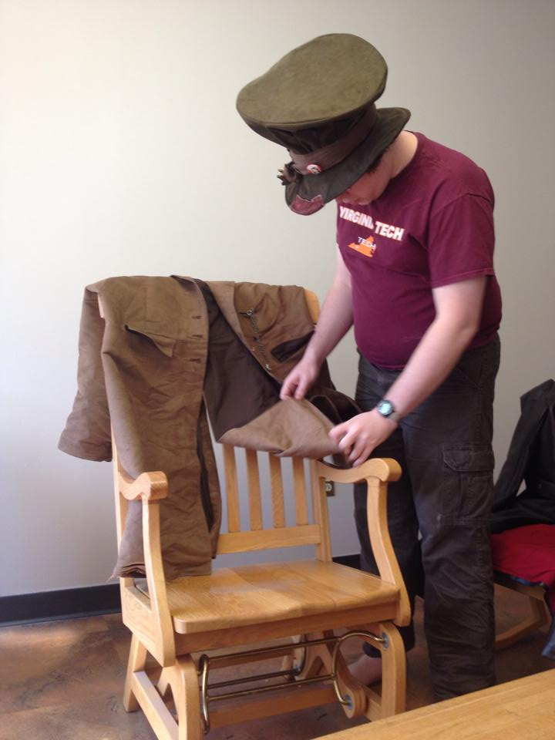
Image 1 Image 2

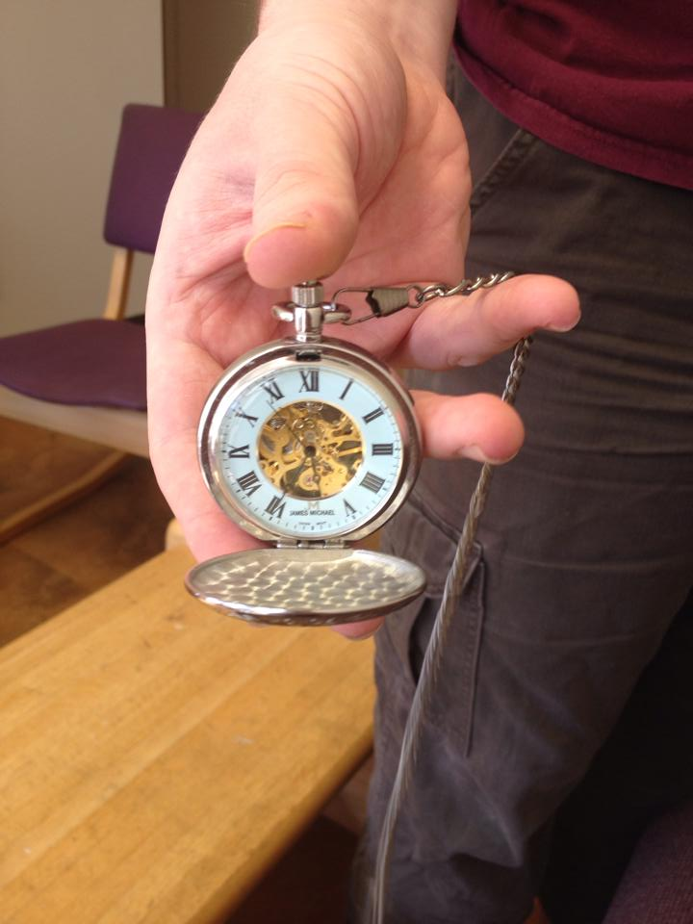
Image 3

Image 1: Ben Blumenthal as The Mad Hatter
Image 2: The trench coats
Image 3: The pocket watch he carries

Katharina Elberti took all images on 23 April 2014.

Audience:
- Members of the Virginia Tech community
- Who have seen The Mad Hatter around campus
- Who have not seen him and are interested in his story

